
DHARMSINH DESAI UNIVERSITY, NADIAD
FACULTY OF MANAGEMENT AND INFORMATION SCIENCE
B.C.A. SEMESTER VI
SUBJECT: (25BCA601)SYSTEM DEVELOPMENT PROJECT
Student Name | Himanshu D Ladha
Roll No | BCA045
Student ID | 23BCUOS055

Project Definition: RestoFlow – A full-stack Restaurant Management Platform.

Company Timing: 11:00 AM to 6:00 PM

Week | Date | Day | Name of the Topic | Signature
Thirteenth Week | 23-02-2026 | Monday | Add the feature of pdf for reports
Thirteenth Week | 24-02-2026 | Tuesday | Changes in theme
Thirteenth Week | 25-02-2026 | Wednesday
Thirteenth Week | 26-02-2026 | Thursday
Thirteenth Week | 27-02-2026 | Friday

External Guide Name: Somil Sir Internal Guide Name: Prof. Rupal Patel
Signature Signature

23-02-2026
- In the restaurant Admin Dashboard, Analytics board, added the feature for downloading the reports in pdf format.
- Day by day reports, Revenue summary, items sales etc things reports’ pdf.
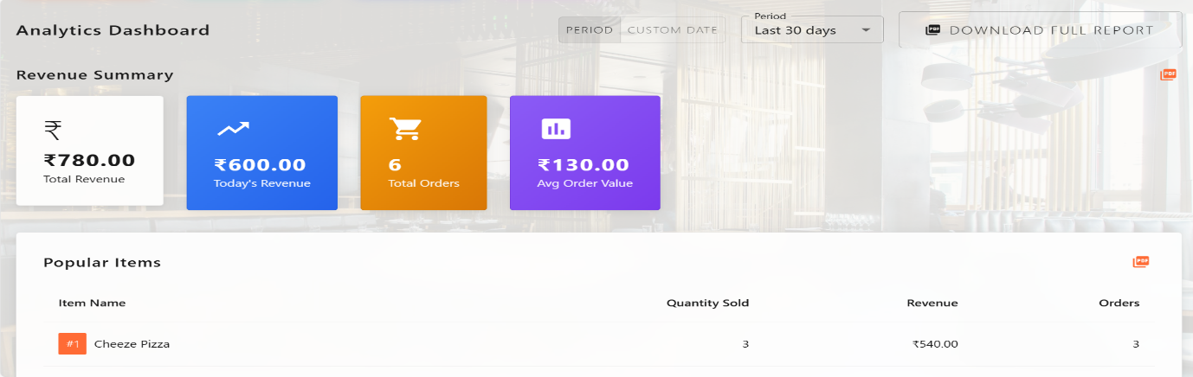
24-02-2026
- Make changes in the menu-cart theme, when customer scans the QR after that pages theme in the main project main theme.
- And bugs fixes.
25-02-2026

